HOW TO NOTIFY POSSESSION OF UNDERWATER HERITAGE ARTEFACTS
INTRODUCTION
These instructions are provided to assist persons who need to notify their possession of protected underwater heritage artefacts. The process of submitting a notification will vary depending on whether an artefact has been previously registered or is unregistered.
PROCESS FOR NOTIFYING PREVIOUSLY REGISTERED ARTEFACTS
Registered artefacts will have one of the following certificates issued under either the Historic Shipwrecks Act 1976 or the repealed Western Australian Museum Act 1959–1964:
Format of certificates issued prior to 1976.
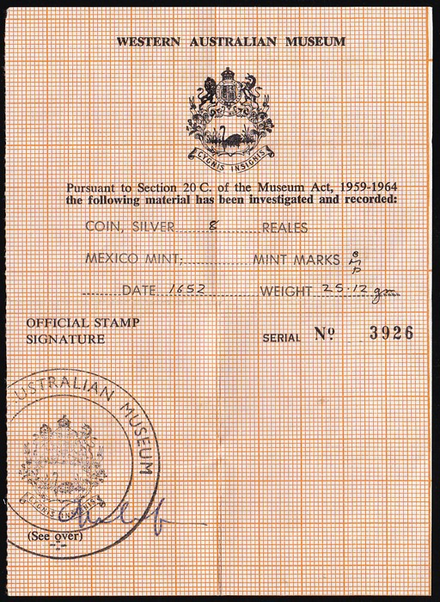
Format of certificates issued between 1976 and 2009.
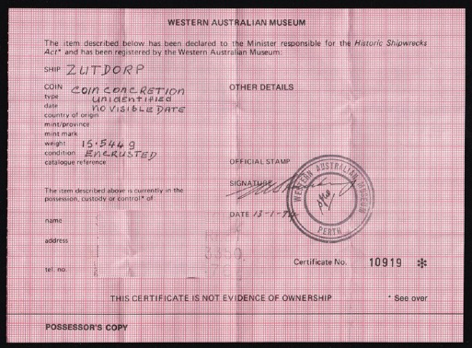
Format of certificates issued after 2009.
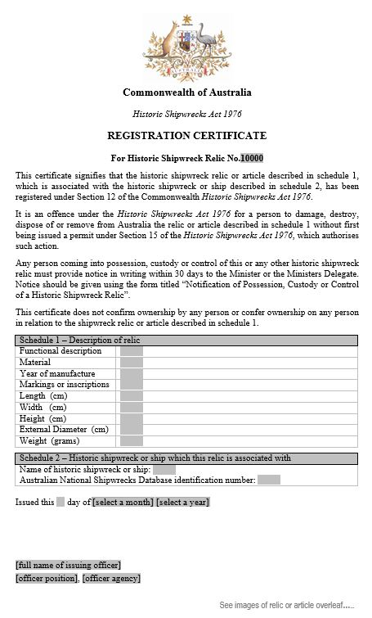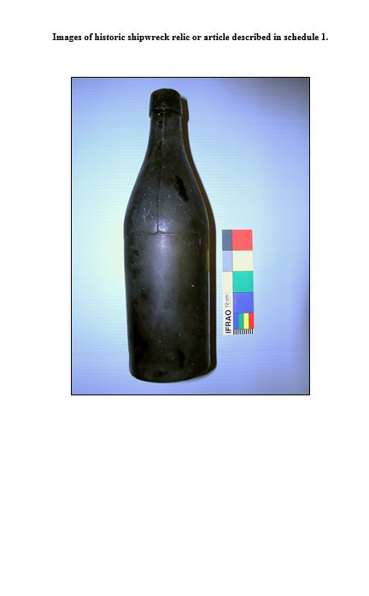
Notification of registered artefacts must be done through the Australian National Shipwrecks Database (ANSDB). The online form can be accessed directly at the following web address:
https://dmzapp17p.ris.environment.gov.au/shipwreck/public/forms/notificationPossession.do;jsessionid=2F9B49808FF577699FC6B119C2CE9DB1?mode=add
The online notification form can also be located on the bottom right hand side shipwreck database search pages (see below).
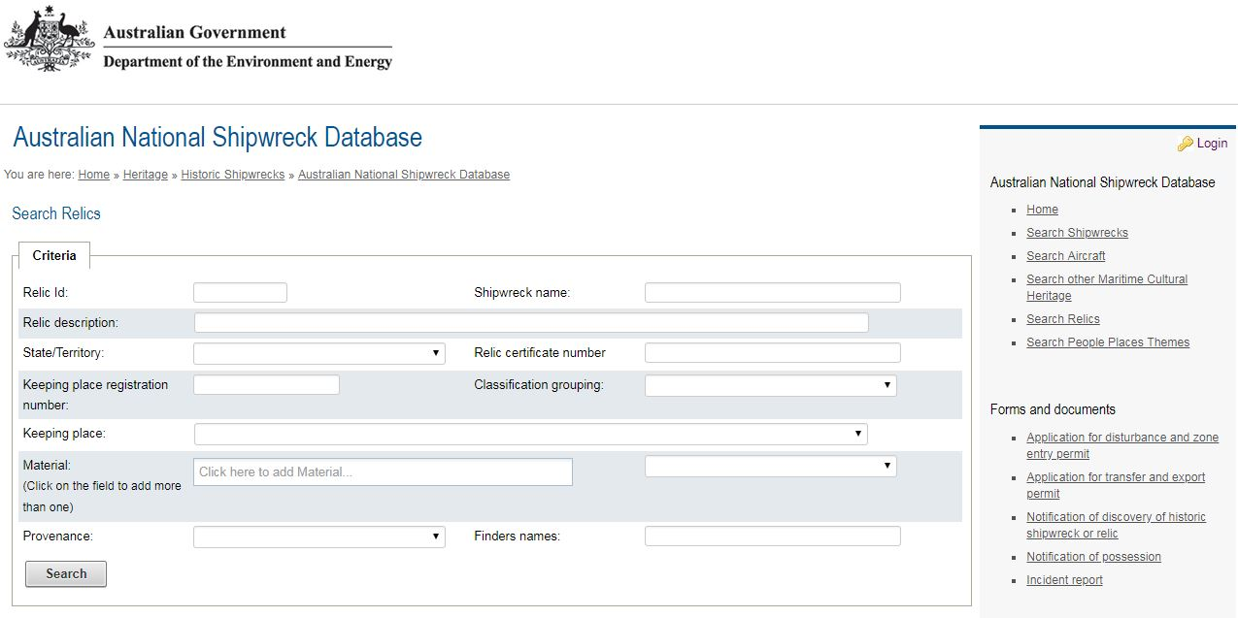
STEP 1.
- Enter contact details for the person in possession and associated business if applicable.
- Click next to proceed when completed.
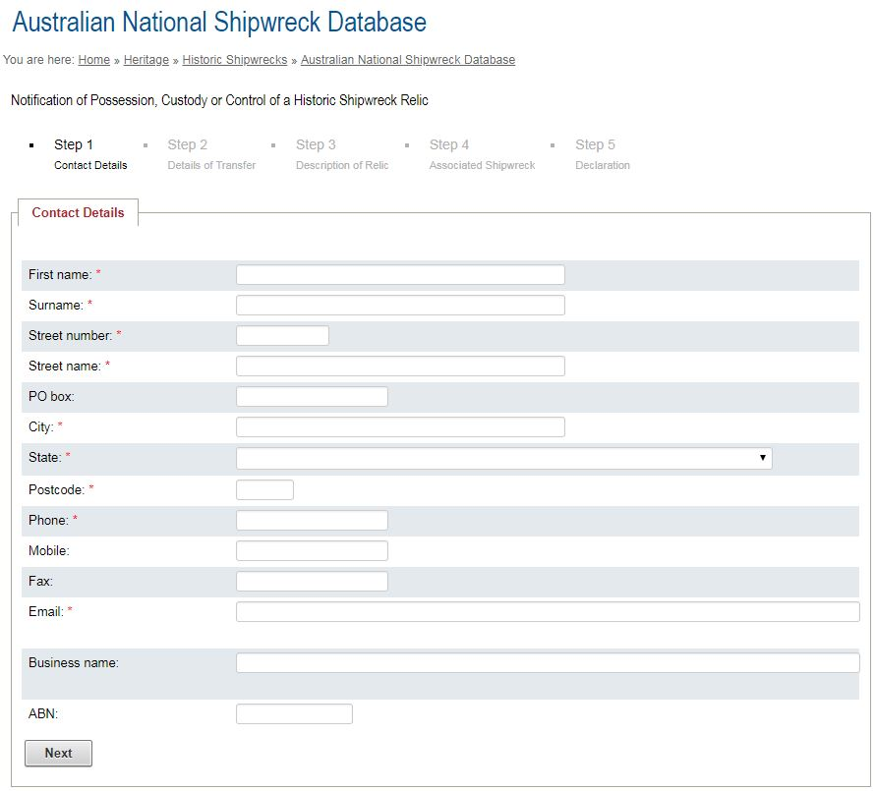
STEP 2.
- For the purposes of this notification, ignore this step.
- Click next to proceed.
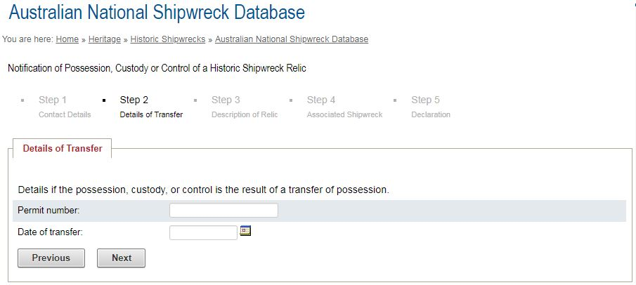
STEP 3.
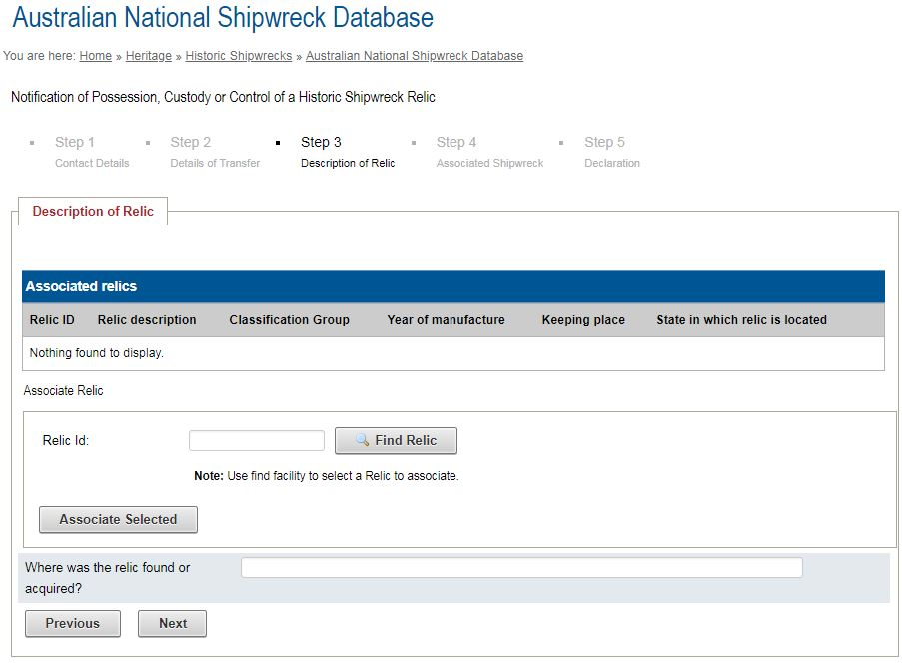
- To locate your registered artefact in the database, click on the ‘Find Relic’ button (above).
- The simplest way to locate registered artefacts in the database is to enter the ‘Relic certificate number’ (for the old certificates issued between 1959 and 2009) or The ‘Relic ID’ number for newer certificates issued since 2009.
- Once you have entered the appropriate number, click on the search button.
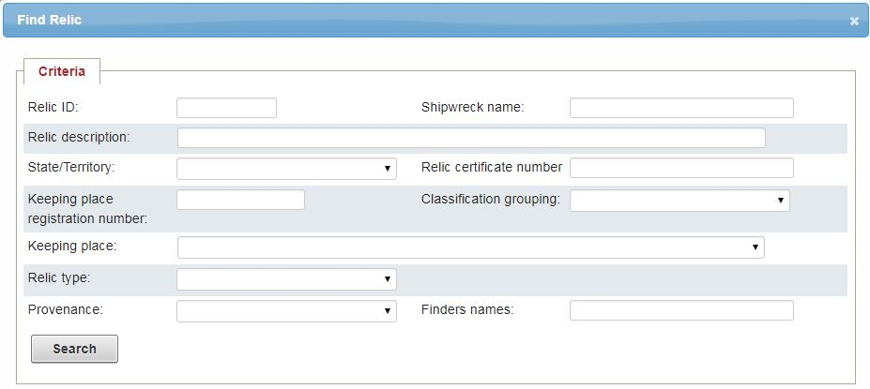
- Your registered artefact should appear in the results section. Note that the number displayed in the results is the unique database number of the artefact. This number can also be used to search and locate the artefact.

- Click on the ‘Relic ID” number (below).
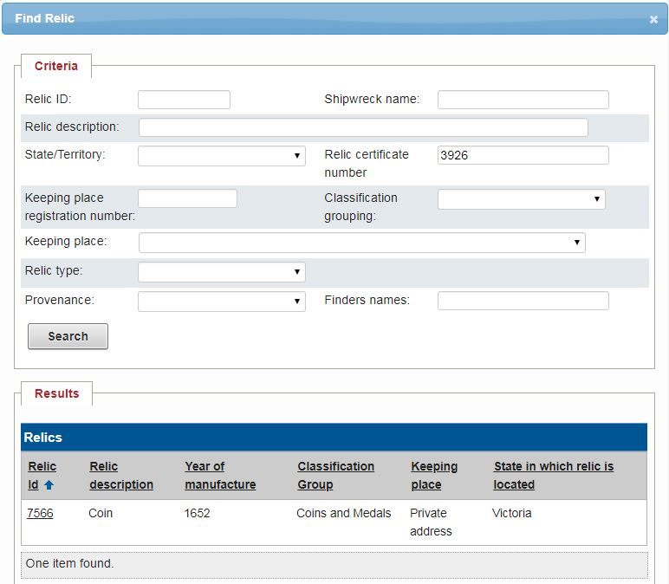
- Click on the ‘Associate Selected’ button to add this artefact to the notification.
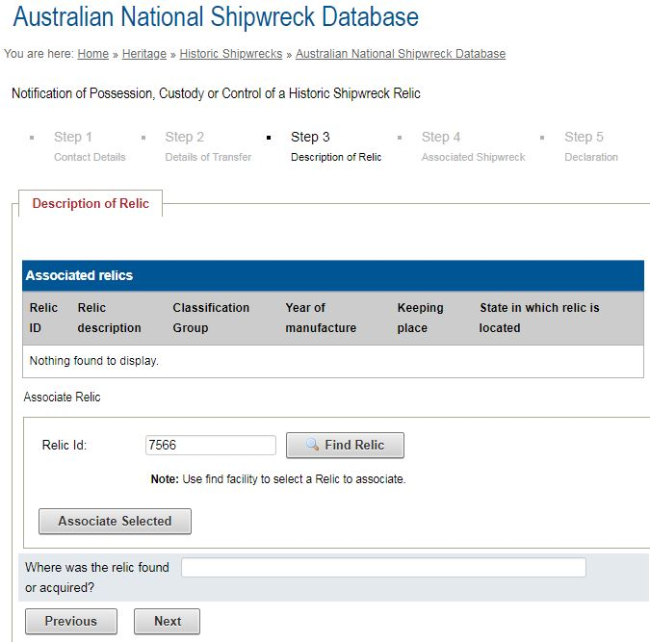
- Your selected artefact will appear in the list of ‘Associated relics’. The process can be repeated to add more artefacts to the list if required.
- Note that you can remove an artefact from the list by clicking the ‘Disassociate’ button.
- Click next to proceed when completed.
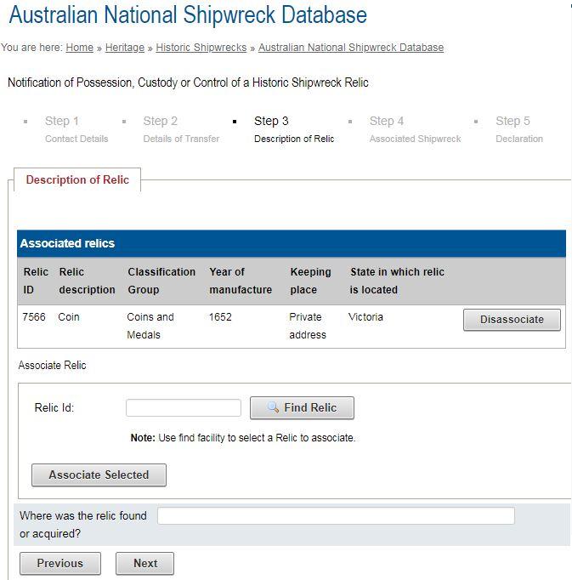
STEP 4.
- Ignore this step as registered artefacts already have this information.
- Click next to proceed.
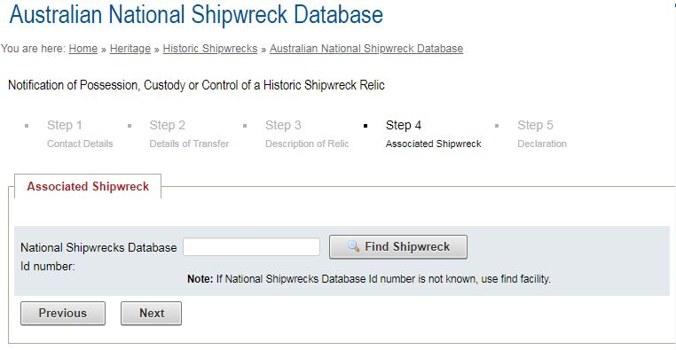
STEP 5.
- Once you have completed the form, you need to click the ‘declaration box’ and click ‘Submit’ to lodge your notification.
- If your notification is successfully lodged, the system will send you an automated confirmation email to the email address you provided in the form.
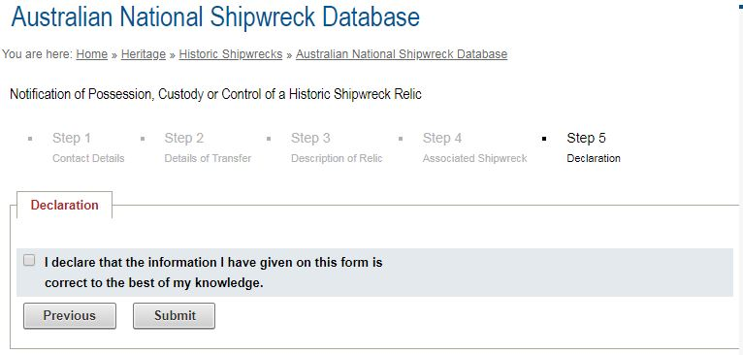
STEP 6.
After 1 July 2019, certificated issues under either the Historic Shipwrecks Act 1976 (Historic Shipwrecks Act) or the repealed Western Australian Museum Act 1959–1964 will not be recognised as evidence of the legal possession of artefacts and cannot be used in the trade, sale or transfer of protected artefacts. All protected underwater heritage artefacts in private possession will require a permit issued under the Underwater Cultural Heritage Act 2018 (the Underwater Heritage Act).
The new permits will allow possession and future transfer of the artefacts within Australia, providing the transferor and transferee notify that they have undertaken the transfer, as required by the Underwater Heritage Act. This requires both parties completing the online notification of possession through the ANSDB.
Current identification images of each artefact/s is required in order to produce a new permits. A permit cannot be issued without the required images. You should consult ‘A guide to photographing underwater heritage artefacts’, which contains the requirements for providing suitable images.
Return of old certificates
In order to be eligible to receive your new permit/s, existing relic certificate/s must be returned by post to the following address;
Underwater Heritage
Australian Government Department of the Environment and Energy
GPO Box 787
CANBERRA ACT 2601
It is recommended that you take a photograph of the old certificate for your records and that you should include a temporary label with the artefact in your possession to allow its identification. This is especially important if you are in the possession of multiple similar looking artefacts.
Submitting images
The simplest way to transmit artefact images is by using the online file transfer site WeTransfer. This service is free providing the files being uploaded are less than 2 Gigabytes in total size. WeTransfer can be found at the following web address: https://wetransfer.com
- Complete the required details including:
  - Email to = UnderwaterHeritage@environment.gov.au
  - Your email
  - Message = i.e. Return of relic certificate/s 1234, 4567, 7890
- Click ‘Add your files’ and upload the artefact images from your computer.
- Click the ‘Transfer’ button to send.
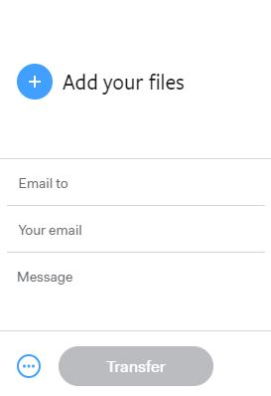
PROCESS FOR NOTIFYING UNREGISTERED ARTEFACTS
Notification of the possession of unregistered artefacts protected under the Historic Shipwrecks Act or the Underwater Heritage Act must be done by completing and submitting the electronic form ‘Notification of possession, custody or control of an historic shipwreck relic’, which is available for download from the historic shipwrecks website in either Microsoft Word or an Adobe PDF formats, at the following web links:
http://environment.gov.au/system/files/resources/db18ccef-2761-470c-bc62-04271e30da98/files/hsa-notification-possession.doc
http://environment.gov.au/system/files/resources/db18ccef-2761-470c-bc62-04271e30da98/files/hsa-notification-possession.pdf
Images of the artefacts must also be provided as per the instructions (above), and specified in ‘A guide to photographing underwater heritage artefacts’.
If you’re a museum or organisation that has many unregistered artefacts to report then the artefact data spreadsheet ‘ANSDB Artefacts work sheet 2019’ can be used in conjunction with the notification form to provide the required information.

